Trauma Informed Approach – Working with Trauma Resource Pack

This resource focuses on understanding the links between Trauma and Attachment as part of our collective development across Lancashire in our aspiration to become a Trauma Informed County.

The Nest Steps workshop and this resource follows on from the Basic Awareness Trauma Aware workshop and has been developed from the feedback we have received over the last 2 years.

The Basic awareness workshop explored Brain Science, impact of trauma and principles of Trauma informed approaches and practice.

This resource will focus on Attachment, Resilience, Working alongside Trauma and Pathways to Recovery.

Introduction
It is totally understandable to feel uncertain when we are working with people who have experienced adversity and trauma. It is normal to fear that we might make things worse or fear opening the door to the adversity they have experienced. It can be challenging to support a person to ‘walk through a minefield’, and therefore it is vital that we understand how our own work can be adversity and trauma informed.
Relationships matter and every contact with someone who has experienced adversity and trauma can be an opportunity for healing and growth. To make every contact count, we need to adopt a professional curiosity about adversity and trauma. It is vitally important to take time to listen to the people we work with, understand what lies behind the behaviours they present with, and avoid jumping to conclusions, making assumptions or offer solutions. To work in an adversity and trauma- informed way, is to be sensitive to the wider context of the person’s life, and how this impacts them, and any support you might be able to give them.

Trauma-informed practice is designed to enhance, and work alongside, existing safeguarding protections, policies, and measures for children and vulnerable adults

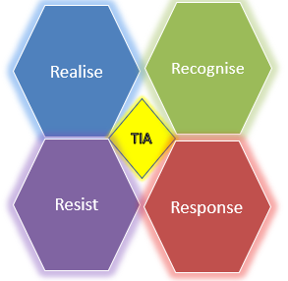

Models of Attachment
Secure attachment is as much about offering a safe harbour of support to turn to when a child is distressed or tired as it is about supporting how they go out and explore the world. With a secure launching pad, security supports the development of a resilient mind. A secure relationship is central to the development of a positive self, empathic and sensitive interaction, and adaptive and flexible emotional regulation skill. As a child becomes a toddler, this sense of security in their attachment relationships in internalised in their brains as a “state of mind” that is secure. Not only do they feel good about themselves, about connecting with others and feel that their needs will be met, but they also feel they will be able to have connections with others. This is the solid sense of self that emerges for those with secure attachment models | The Insecure - Avoidant Model  Wary and distrustful of intimacy and close relationships, possibly sabotaging or completely avoiding close relationships  Fiercely self-reliant, can burn up friendships and does not like to be comforted by others.  Unsure if they can rely on other people  Internally feels a sense of “I don’t need this person for anything, because I have learnt that they give me nothing when I need connection or comfort”  Feeling a sense of disconnection for others and also from their own emotions and needs
The Insecure-Ambivalent Model  Develop sense of anxiety and uncertainty about whether they can depend on their caregivers  Have a feeling of insecurity within the attachment relationship which continues forward in the child’s interaction with the larger social world, leaving them often prone to being clingy, jealous or dependent on others  Ongoing uncertainty that others can’t be relied upon for connection.  Has very low self-esteem  Often may feel mystified when people want to be their friends  Often incapable of calming their fears or soothing themselves and can rely on others to help when they are upset  Start romantic relationships anxiously and worry about whether they are worthy of the person they are with  Feelings of panic and being abandoned where there is distance or conflict in relationship  Being in love is filled with anxiety but being without it is unbearable | The Insecure – Disorganised Model  Has difficulty tolerating and regulating emotions  Learns that intense emotions are disorganising  Has difficulties making sense of own internal and interpersonal world  Has trouble in social communication and relationships  Has difficulties with academic reasoning tasks  Tendency toward interpersonal violence  Predisposition to dissociation  Difficulties coping with stress  Has impaired neural integration due to abuse and disorganised experiences  Increased chance of risky behaviours such as substance use, self-injury  Fragmented sense of self  Interpersonal relationships may feel unreliable

Symptoms of Attachment Difficulties or Trauma

There are numerous symptoms that could suggest attachment difficulties or trauma, and these can be like other disorders so getting a professional assessment is vital for diagnosis. Often children can be labelled as ‘naughty’ due to the behaviours they exhibit, but remember, behaviour is a means of communication. Like any other behaviour management strategy, it’s vital we look behind the behaviour to what is driving it. Behaviour is often driven by fear and anxiety, as well as a deep-rooted sense of shame.

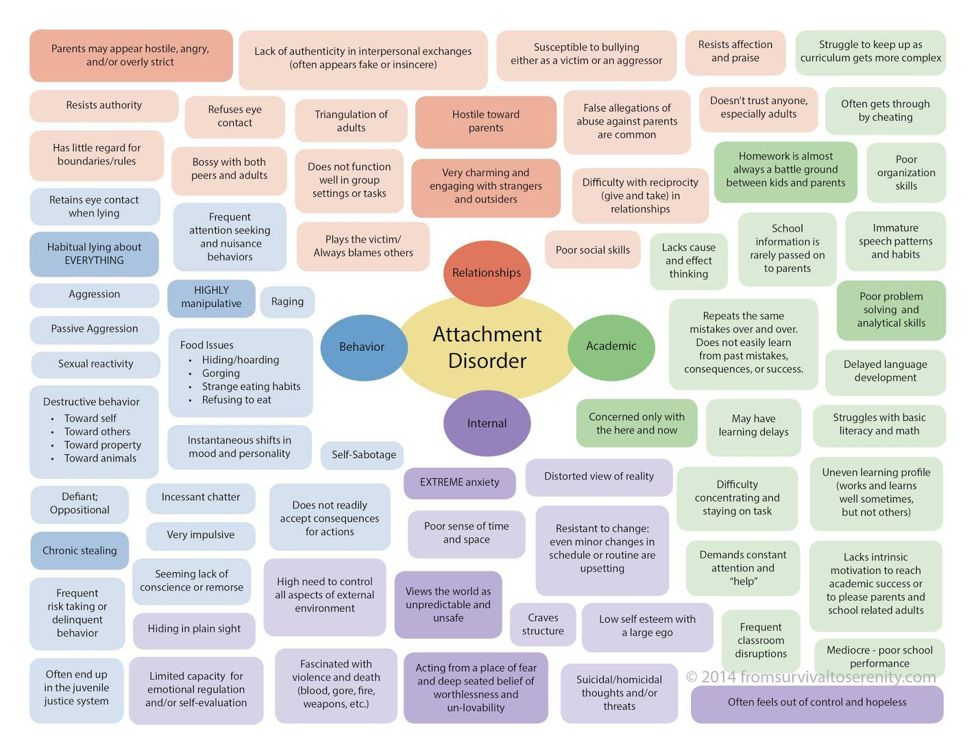

Resilience
Resilience is defined as: Normal development under difficult conditions (Brigid Daniel & Sally Wassel,2002)

Secure Base  Relation between secure attachment and resilience  Access to both intellect and emotion  Able to process information on both levels simultaneously  Ability to build a narrative of one’s life is a significant resilience factor.  The implications for this in practice is that we need to emphasise building a protective network of support from all the resources available, adding to them with professional support where necessary. | Friendships  Resilience is associated with having generally positive peer relationships. It is important for resilience that children have as many sources of support as possible, and friendships offer uniquely equal relationships for children. Friendships provide:  Contexts in which to acquire and practice social skills  Self-knowledge and knowledge about others  Emotional support in times of stress  The basis for future intimate relationships | Talents and interests  Tend to build self-esteem.  Self-esteem is an interpersonal issue  feel good about themselves  need to be able to operate in relationships with others.  Linked to self-efficacy  Balance between the ‘ideal’ self and the ‘perceived’ self  It is not just about being good at something; it is about valuing what you are good at
Positive Values  Holding pro-social values and having the capacity to be helpful, caring and responsible is associated with resilience. Essentially pro-social behaviour is not based on the expectation of external rewards and includes  Helping others  Comforting others in distress  Sharing with others | Social Competencies  Possessing and using the ability to integrate thinking, feeling and behaviour to achieve social tasks and outcomes valued in the host context and culture.  Resilience:  Autonomy, also known as internal locus of control  Capacity for problem solving  Sense of purpose and future  Learnt in the context of an attachment relationship and is then extended to peers and other adults. | By fostering resilience, we can reduce risk and support recovery when the right supports are in place.  Resilience is the ability to bounce back and with appropriate support and help, people can heal and thrive despite past experiences.

Resilience can be built through:

- Healthy and supportive relationships
- Taking care of ourselves
- Asking for help when we need it
- Supportive relationships with at least one parent
- Supportive relationships with siblings and grandparents
- A committed non-parental adult who takes a strong interest in the young person and serves as an ongoing mentor and role model
- A capacity to develop and reflect on a coherent story about what has happened and is happening to them
- Interests
- Positive experiences in school
- Positive friendships
- A capacity to think ahead and plan in their lives
- How can these relationships and experiences impact on later life?

Key questions to assess sources of resilience

What things are going well in this person's life? | To whom is this person important? Who is important to this child?  Has the child a realistic way of contacting this adult when necessary?
Who are the people who play a positive part in the individuals life? (At home, in the neighbourhood, school or further afield) | In which fields can the child find a sense of achievement?
Is there a concerned adult outside the home who has very regular contact with the child? | Does the child have an adult outside the home that she or he likes and trusts?
Has anyone discussed a fallback safety plan for an older child who may occasionally be at harm due to episodes of parental substance misuse or domestic violence? | Do these adults have the confidence and know-how to look for help if they are worried?
Does the child relate fairly easily to peers of his or her own age? (Check this through adults who know the child well) | Do there appear to be problems of bullying or being bullied? (A possible indicator of other abusive experiences in the individual's life)
Does the child have hobbies and interests that are encouraged and supported? | How does the child get on in school – socially as well as academically?
Has the school been briefed adequately on the individuals home situation? | Has the school’s special knowledge of the child been adequately tapped in assessing the individuals developmental progress and vulnerability and strengths?
Does the primary caregiver have people they trust and can rely on for help in moments of stress and crisis? | Does the caregiver have role identities beyond that of caregiver? (Is she/she a club  member, employee, volunteer, friend, church member, etc)
Does the caregiver have a record of using help well or of ambivalence or defensiveness in the face of help? | Has the caregiver had a chance to articulate his/her worries and views as part of the negotiation or formulation of a plan to address child protection and welfare concerns?

Stages of Trauma Recovery

Most important, the key to healing from traumatic experiences in childhood is achieving these ‘stage-one’ goals of personal safety, genuine self-care, and healthy emotion regulation capacities. Importantly, the first stage of recovery and therapy is not about discussing or ‘processing’ memories of unwanted or abusive experiences, let alone ‘recovering’ them.
Judith Herman’s three stages of recovery from severe trauma - Scoglio_2015.pdf (self-compassion.org)

Stage 1
The first stage of dealing with and overcoming trauma-related problems is about:
Getting a ‘road map’ of the healing process.
Establishing safety and stability in one’s body, one’s relationships, and the rest of one’s life.
Tapping into and developing one’s own inner strengths, and any other potentially available resources for healing.
Learning how to regulate one’s emotions and avoid emotional overwhelm
Developing and strengthening skills for managing painful and unwanted experiences, and minimizing unhelpful responses to them

Stage 2
This stage of recovery is often referred to as ‘remembrance and mourning.’ The main work of stage two involves:
• Reviewing and/or discussing memories to lessen their emotional intensity, to revise their meanings for one’s life and identity, to reduce flashbacks and nightmares if they are ongoing problems.
• Working through grief about unwanted or abusive experiences and their negative effects on one’s life.
• Mourning or working through grief about good experiences that one did not have, but that all children deserve

Stage 3
The third stage of recovery focuses on reconnecting with people, meaningful activities, and other aspects of life.
The person having learned about impacts of abuse during stage 1 and 2 that previously made it difficult for people to do this makes this easier.

Recovery Triangle

Instability/Chaotic  It is vital that professionals utilise varying resources to support the individual to understand boundaries, they are revisited frequently to support that understanding and consequences of boundaries are clearly shared with the individual. – how are boundaries shared with the individuals in your service? What could be the impact? | Relationship building/Trust/Shame  The maintenance of structure, routine and boundaries are key elements of both relationship building and trust for an individual - Without a positive routine to follow, it can be easy to fall back into old habits and a dysfunctional lifestyle. Getting used to a new routine may replace feelings of fear with feelings of stability. Routine provides a sense of security when life may feel like it’s been turned upside down or when an individual may feel especially vulnerable. | Working through Trauma  It may be necessary for an individual to require specialised intervention/treatment as part of their recovery from Trauma- this may include substance misuse intervention, mental health support etc – it may be that an individual engages in substance misuse as a complex coping mechanism to subdue memories and feeling that evoke pain, hurt and fear. Working through Trauma is a complex process that is individualistic in both the process for the individual and professionals should not assume a one size fits all process. Are services flexible enough to offer individual services?
Insight/Awareness  Insight is an understanding and explanation of our current behaviour's, thoughts, feelings, and relationship patterns based on our past experiences.  Insight is the answer to the ‘why’ questions, such as ‘Why do I feel this way?’ or ‘Why do I have this relationship?’, ‘Why do I engage in these behaviours, when I know it’s bad for me?’, ‘Why did I form this pattern in the first place?’. | Future Planning  Goal setting – A sense of purpose and Achievement  Goal setting helps an individual to remain motivated and move through recovery in a healthy and positive way.  When a person starts to set goals in recovery, they give themselves something to strive for. This helps a person learn and grow throughout their journey in recovery. Goal setting can support Personal strength.  Individuals might go on to feel more confident, capable, or assertive than before and utilise choice within their life.  Relating to others. - Individuals might find it possible to develop closer bonds with others or grow their support network though a greater sense of self worth and value. | Ultimately the recovery triangle seeks to support an individual to achieve Independence, confidence, self-worth, and positive coping strategies in life.

Talking about Trauma

Regardless of your role or professional status talking about trauma is critical in becoming a Trauma Informed Service- While trauma is very common, not everyone experiences it. However, it is so common that even if we don’t experience it directly, trauma can still affect us
Because trauma is so common and occurs in so many different forms, we cannot regard it as an issue that affects only a ‘minority’ of people. Nor can we see it as an ‘individual’ misfortune experienced by someone who has something `wrong’ with them in the first place

While ‘talking about trauma’ can be confronting, it becomes easier when we have a foundation of basic knowledge. We want to build a society where the whole of society is able to interact and relate in a trauma-informed manner.
Protect staff wellbeing: Since trauma-informed care requires staff to engage with people’s traumatic experiences, it may cause them distress as well. You therefore need to promote a culture that supports staff wellbeing. This includes careful supervision and debriefing, ensuring no-one’s workload is overwhelming, and leadership which fosters a culture of trust, so that staff can say when they are struggling to cope without fear of being penalised.

Listening and Responding

Give them time. Let them talk at their own pace – it's important not to pressure or rush them | Focus on listening. Try to respect what they are choosing to share, rather than asking lots of questions.
Accept their feelings. For example, allow them to be upset about what has happened. · Don't blame them or criticise their reactions | You might wonder why they didn't do something differently, but they survived however they could at the time
Use the same words they use. People vary in how they prefer to describe their experiences. For example, it's their choice whether to talk about being a 'victim' or 'survivor' of trauma | Don't dismiss their experiences. For example, don't tell them not to worry about things or that it could be worse – this isn’t usually helpful to hear
Try to remember that people can't choose what they find traumatic or how they're affected | Only give advice if you're asked to. They might prefer to simply hear that you believe them and are there for them

References

Howe, D., Brandon, M., Hinings, D., Schofield, G.(1999): Attachment Theory, Child Maltreatment and Family Support. London: Macmillan.

Bowlby, J. (1980): A secure base: Clinical Applications of Attachment Theory. London: Routledge.

Brigid Daniel & Sally Wassell(2002): Assessing and Promoting Resilience 1 – 3. Jessica Kingsley.

Trauma Informed Veteran Aware Training (TIVAT) – All Call Signs

B.A. van der Kolk, The Body Keeps the Score: Brain, Mind and Body in the Healing of Trauma (New York: Penguin, 2014), p. 113.

Reference list from Workshop

Attachment in children and young people- Research in Practice
Emotion Coaching Resources for Professionals (emotioncoachinguk.com)
B.A. van der Kolk, The Body Keeps the Score: Brain, Mind and Body in the Healing of Trauma (New York: Penguin, 2014), p. 113.
M. D. S. Ainsworth, S. M. Bell, and D. J. Stayton, “Infant–mother attachment and social development: Socialization as a product of reciprocal responsiveness to signals,” in The Introduction of the Child Into a Social World, ed. M. P. M. Richards. (London: Cambridge University Press,1974), 99-135.
E. Meins, “Sensitive Attunement to Infants’ Internal States: Operationalizing the Construct of Mind-Mindedness,” Attachment & Human Development, 15:5-6, (2013): 524-544.
L. M. Bomber, Inside I’m Hurting, Practical Strategies for Supporting Children with Attachment Difficulties in Schools. (London: Worth Publishing, 2007), p. 87
Bowlby, J. (1969). Attachment and Loss, Vol. 1: Attachment. Basic Books: New York
R. G. Erksine, (1998) Attunement and involvement: therapeutic responses to relational needs. International Journal of Psychotherapy, Vol. 3 No. 3,
Tronick, E. (1989). Emotions and Emotional Communication in Infants. American Psychologist. Vol.44(2): 112-119
Read J, Hammersley P, Rudegeair T (2007) Why, when and how to ask about childhood abuse. Advances in Psychiatric Treatment, 13: 101–10.
Trauma Informed Veteran Aware Training (TIVAT) – All Call Signs
Neff, K. D. (2003b). Self-compassion: An alternative conceptualization of a healthy attitude toward oneself. Self and Identity, 2, 85-102. doi:10.1080/15298860309032
Neff, K. D., Hsieh, Y., & Dejitterat, K. (2005). Self-compassion, achievement goals, and coping with academic failure. Self and Identity, 2, 263-287. doi:10.1080/13576500444000317
Dutra, L., Callahan, K., Forman, E., Mendelsohn, M., & Herman, J. (2008). Core schemas and suicidality in a chronically traumatized population. Journal of Nervous and Mental Disease, 196, 71-74. doi:10.1097/NMD.0b013e31815fa4c
Herman, J. L. (2012). Shattered shame states and their repair. In J. Yellin & K. White (Eds.), Shattered states: Disorganized attachment and its repair (pp. 157-170). London, England: Karnac Books
CTRN UK (traumarecoverynetworkuk.org)
Foundation (resilientcommunitieswi.com)
The Power Threat Meaning Framework: a radically different perspective on mental health | www.basw.co.uk
Judith Herman’s three stages of recovery from severe trauma - Scoglio_2015.pdf (self-compassion.org)
Knight, C. Trauma Informed Practice and Care: Implications for Field Instruction. Clin Soc Work J 47, 79–89 (2019). https://doi.org/10.1007/s10615-018-0661-x
New Leaf Center. Trauma bonds: why people bond to those who hurt them.
Yuval-Davis, N. (2004), Borders, boundaries and the politics of belonging, in S. May, T. Modood
& J. Squires (eds.), Ethnicity, nationalism and minority rights. (pp. 214-230). Cambridge:
Cambridge University Press
Documents and Training Materials: Infographics | BPS
Schofield, G., & Beek, M. (2014). Promoting attachment and resilience: A guide for foster carers and adopters on using The Secure Base Model: BAAF
Baumeister, R. F., & Leary, M. R. (1995). The need to belong: desire for interpersonal attachments as a fundamental human motivation. Psychological bulletin, 117(3), 497–529.
Beyond a trauma-informed approach and towards shame-sensitive practice (shameandmedicine.org)

